TIM WHITE

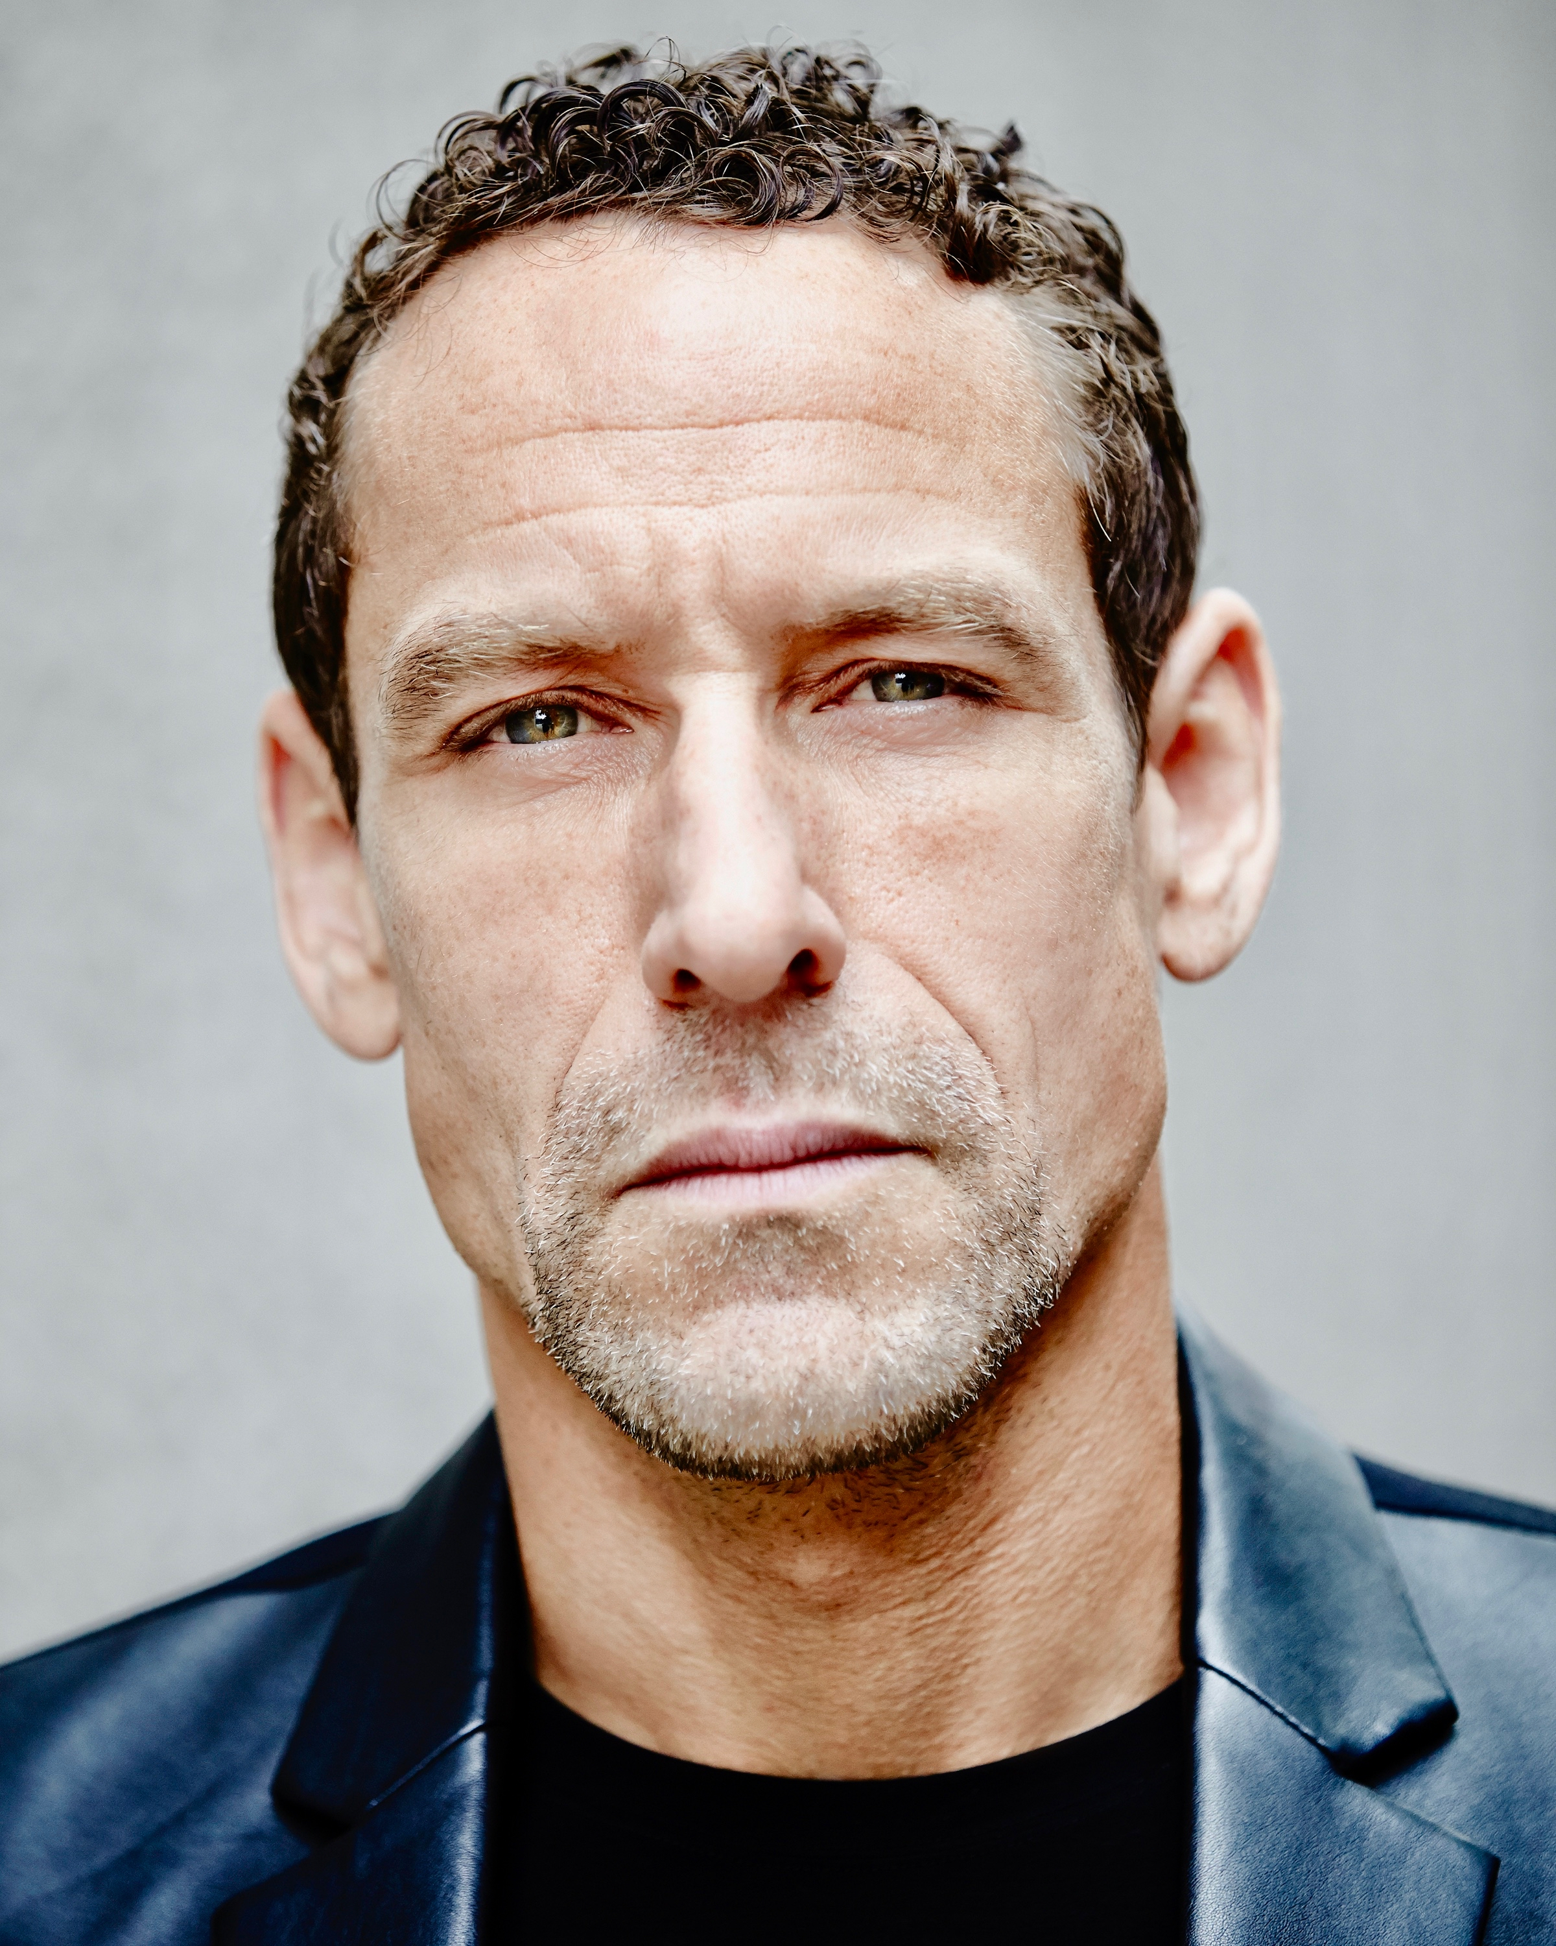

212 Kenilworth Ave
Toronto, ON
416 892 5448
tim@thisismusic.ca
Personal Website
IMDB

VOICE RESUME

I began doing voiceover in 2003.
My training as a musician and composer helps with hearing the nuances necessary to communicate emotion in a script.
I’ve been fortunate to learn from a number of talented directors, and in 2009 began directing sessions for Imprint Music, a professional post-production studio in downtown Toronto.

Thank you for your consideration.

TRAINING

Andy Roth – Private Coaching
Stevie Vallance - Private Coaching
Christian Goutsis – Private Coaching
Tracey Hoyt - Private Coaching
Susan Hart - Weekend Animation intensive
MOCAP U - Weekend MOCAP Intensive

CLIENTS (select)

Advertising:

Advil
Purolator
Unilever
World Vision
Michelob
Labatt
Toyota
Ford
Nissan
Bell
Chevrolet
Expedia
Kraft
GM
Tim Hortons
OLG
CAA
Swiss Chalet
Government of Canada

Gaming:

UBISOFT Starlink: Battle For Atlas (voice of JUDGE)

Narration:
CBC, CTV, DISCOVERY

