HUGH DILLON
Biography

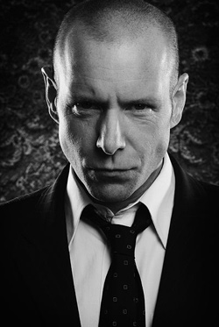
Combining acting with a distinguished career as a singer songwriter, Hugh Dillon earned notoriety as the lead singer in the multi-platinum punk rock band, the Headstones. It was early on in the band’s success when Hugh caught the attention of legendary filmmaker Bruce McDonald (Highway 61, Roadkill). Bruce cast Hugh in Dance Me Outside in 1994. Next came his critically acclaimed lead performance as Joe Dick, in McDonald's 1996 feature film, Hard Core Logo. Quentin Tarantino saw it at the South by Southwest Film Festival in Austin, TX and decided on the spot to distribute the movie through his company Rolling Thunder, bringing international attention to the indie classic and its lead actor.
In 2004, Debra Granik (Winter’s Bone) cast Hugh to star opposite Vera Farmiga (The Departed, Up in the Air) in the Sundance Film Festival award-winning movie, Down To The Bone.
Hugh's ability to capture honest and realistic portrayals of complicated characters has been his calling card. In 2007, the Gemini/CSA winning actor scored the lead role as Mike Sweeney in the dark and twisted serial Durham County (The Movie Network), which lead to his breakout role as Ed Lane in CBS and CTV’s Flashpoint, which aired its fifth season in late 2012.
In early 2013, Dillon joined the cast of AMC’s The Killing, as Francis Becker, going head to head with Peter Sarsgaard. He simultaneously portrayed a mysterious CEO on the second season of Showcase’s sensational sci-fi police drama Continuum (Syfy US and UK). In 2014, Hugh joined the cast of the DirecTV series Things You Shouldn’t Say Past Midnight, based on the play by Peter Ackerman. He followed that up with CBC’s wartime drama X Company, now airing its second season, based upon the real events of Canadian spy school Camp X during World War II, airing on CBC.
In 2015, Dillon continues to challenge and push the boundaries of his creativity, taking a hands on approach to developing and producing unique stories, such as the new short film The Offer and Issues, which premiered at the Toronto International Film Festival.
Following a celebrated return to the stage with the Headstones, 2012 saw Dillon back in the studio, recording their first album in 10 years, Love + Fury. Their single longwaytoneverland skyrocketed to #1 on Active Rock Radio. The album debuted at #7 in its first week, the band’s first Top 10 release. Feeding off of their passionate fans, the band quickly went to work on their latest album One In The Chamber Music, released late 2014 on Universal Music and via crowd-funding platform PledgeMusic, scoring them 301% of their funding goal. Their latest offering is the band’s first ever vinyl release, a new two song EP.

- 2016

